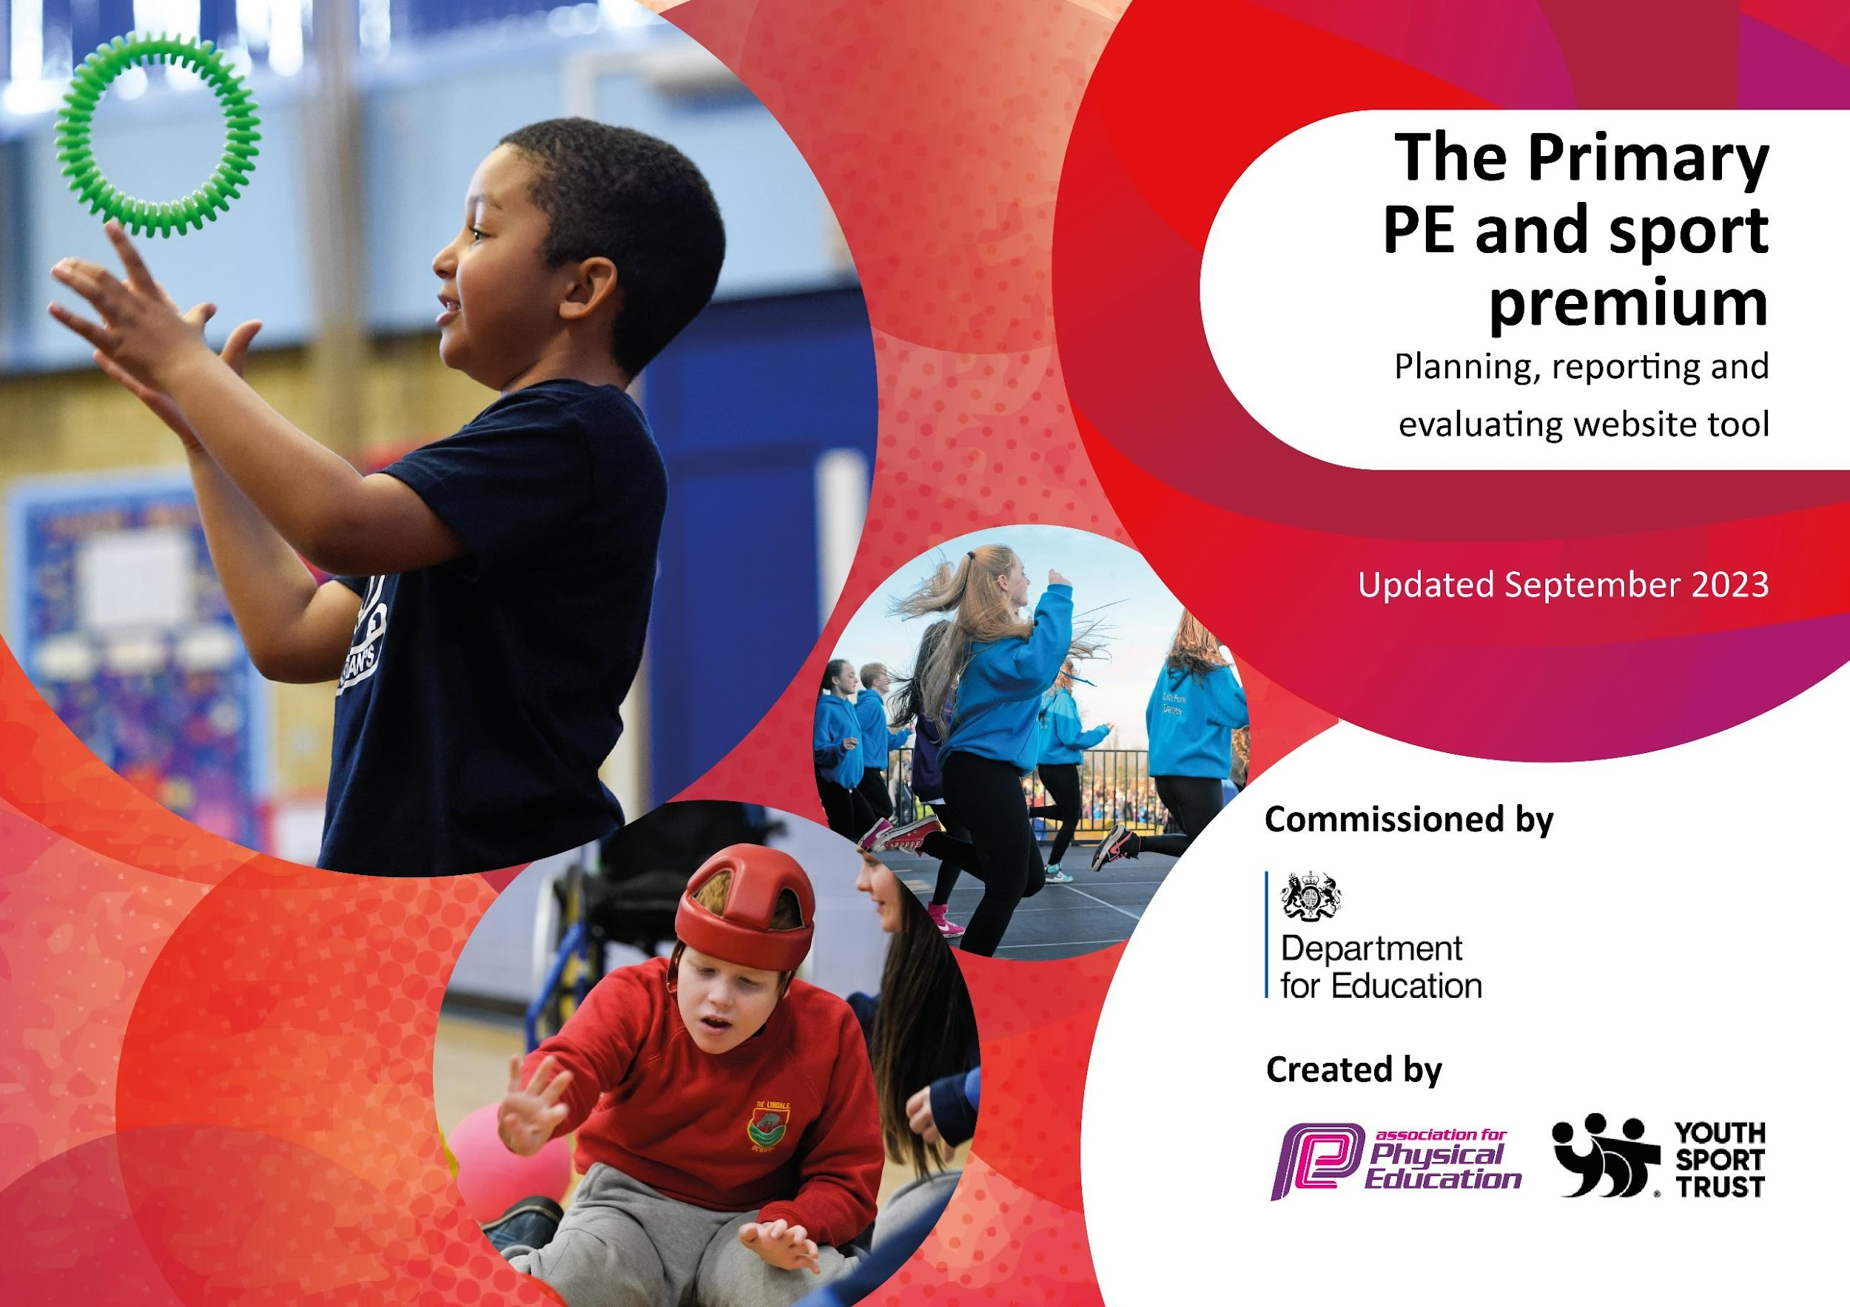

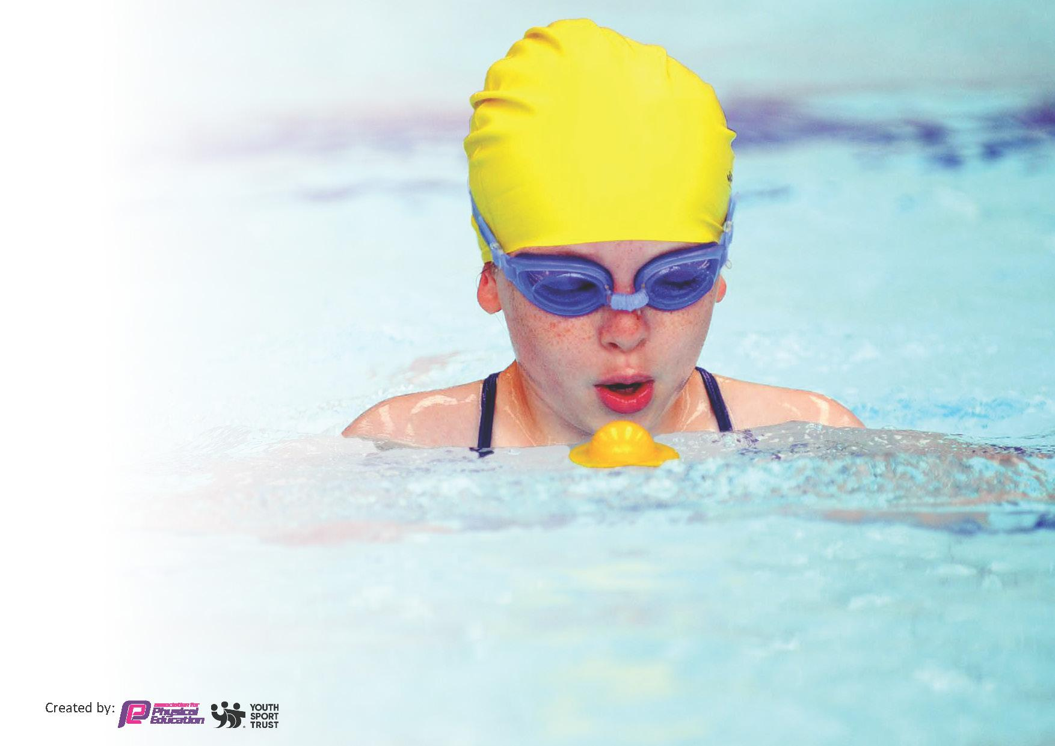
This template can be used for multiple purposes:
by:
- It enables schools to effectively plan their use of the Primary PE and sport premium
- It helps schools to meet the requirements (as set out in guidance) to publish information on their Primary PE and sport premium
- It will be an effective document to support Ofsted inspections enabling schools to evidence progress in Physical Education (PE) and evidence swimming attainment, which forms part of the PE National Curriculum. We would recommend schools consider
the Intent, Implementation and Impact of any spend, as examined within the Education Inspection Framework.

It is important that your grant is used effectively and based on school need.

Schools must use the funding to make additional and sustainable
improvements to the quality of the PE, School Sport and Physical Activity (PESSPA)
they offer. This means that you should use the Primary PE and sport premium to:

- Build capacity and capability within the school to ensure that improvements made now will benefit pupils joining the school in future years
- Develop or add to the PESSPA activities that your school already offers.

The Primary PE and sport premium should not be used to fund capital spend projects; the school’s core budget should fund these. Further detail on capital expenditure can be found in the updated Primary PE and sport premium guidance.
Key priorities and Planning 2025 2026

Action – what are you planning to do | Who does this action impact? | Key indicator to meet | Impacts and how sustainability will be achieved?
To actively monitor the revised PE LTP through regular drop ins for the team and constructive feedback on improvement.  To continue to invest heavily in good quality PE equipment to ensure reviewed LTP can be taught fully.  To improve pupils’ understanding and application of the rules, tactics, and strategies in team and individual games, promoting fair play, cooperation, and physical literacy.  To broaden pupils’ experience of a range of sports and activities by introducing non-traditional and inclusive opportunities (e.g. skateboarding, jiu-jitsu, skipping, and other emerging sports) to inspire lifelong participation and enjoyment in physical activity.  To increase participation in competitive sport by strengthening the role of the PE lead in coordinating and embedding inter-school competitions, ensuring all pupils have regular opportunities to represent the school and experience healthy competition. | HT and PE Lead  HT and PE Lead  HT and PE Lead  HT and PE Lead  HT and PE Lead | Key Indicator 1: Increased confidence, knowledge and skills of all staff in teaching PE and sport.  Key Indicator 2: Engagement of all pupils in regular physical activity Key Indicator 1: Increased confidence, knowledge and skills of all staff in teaching PE and sport.  Key Indicator 3: the increased confidence, knowledge, and skills of all staff in teaching PE and sport;  Key Indicator 4:a broader experience of a range of sports and activities for all pupils; and  Key Indicator 5: increased participation in competitive sport.  . | Feedback will be given to SLT following monitoring throughout the year. This will lead to further adjustments, support to be put in place as necessary.  Revised LTP will be able to be delivered fully.  Increase competitive sport through developing secure knowledge and skills in games e.g. hockey and rugby. In the summer term a focus on javelin, discuss and athletics in addition to cricket and rounders. These changes will also ensure all pupils are prepared for transition into KS3.  PE Lead to run CPD and model effective teaching of game rules and tactics and include team teaching with class teachers so staff gain further confidence and knowledge.  Track and monitor attendance including a focus on vulnerable and SEND groups. Pupil voice feedback and ideas for new non-traditional sports to inspire further participation and excitement around PE, sport and movement.  Monitor and track the number of pupils taking part, number of teams entered e.g. not just team a. Monitor PE leads tracking of events use as evidence that we’ve embedded internal competitions within the partnerships well as external competition and county trials.
Planned Expenditure throughout 2025 2026:
External Clubs |  | £5,000.00
Dance and Movement |  | £400.00
Basketball Events |  | £737.00
Transport |  | £440.00
Gross Motor Skills Development |  | £700.00
Non Traditional Sporing Opportunities |  | £2000
Partnership events and coaches |  | £1,000.00
New equipment |  | £4,400.00
Playground equipment |  | £1,500.00
EYFS Equipment |  | £2,500
Total |  | £18,477

Head Teacher: | Mrs Ritson
Subject Leader or the individual responsible for the Primary PE and sport premium: | Miss Witherspoon
Governor: | Mrs Nicholson
Date: | July 2025

