Do you believe homework is an important part of primary school life?
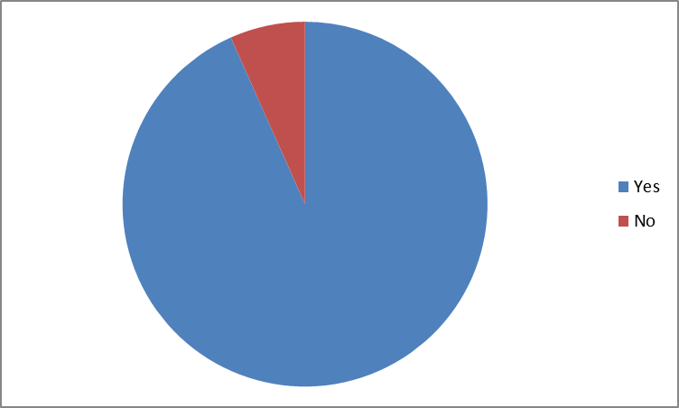
If you answered yes, please tick your reason as to why you think it is important:
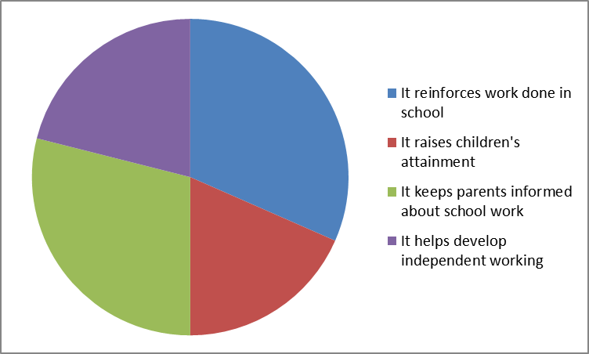
Do you have access to online homework?
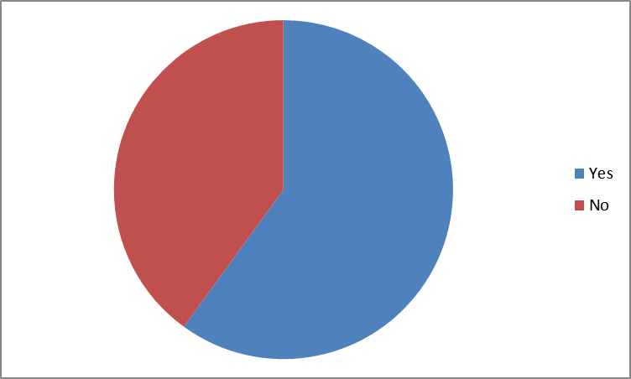
How often do you access Tapestry Online Learning Journal?
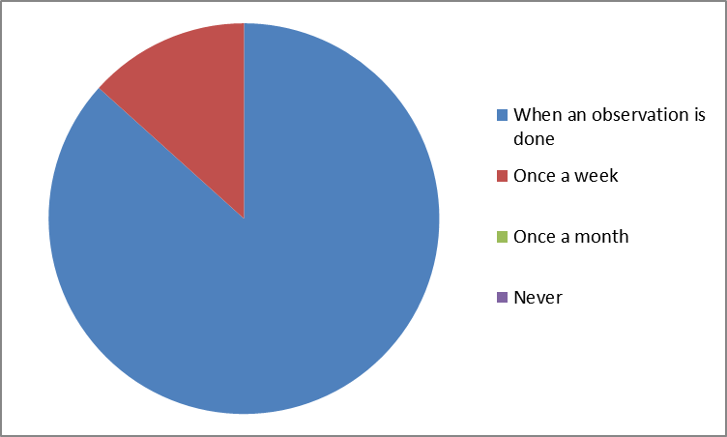
Do you complete Tapestry Challenges each week?
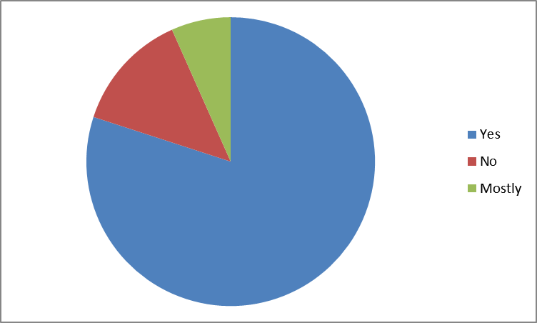
How often do you listen to your child read each week?
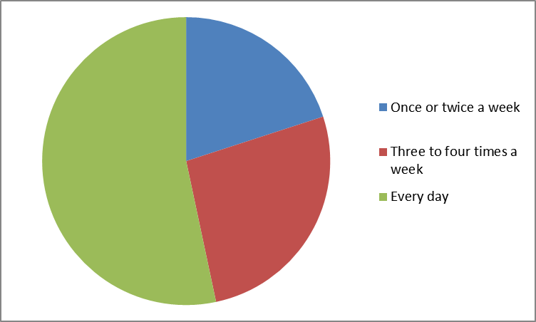
How confident are you in supporting your child with reading?
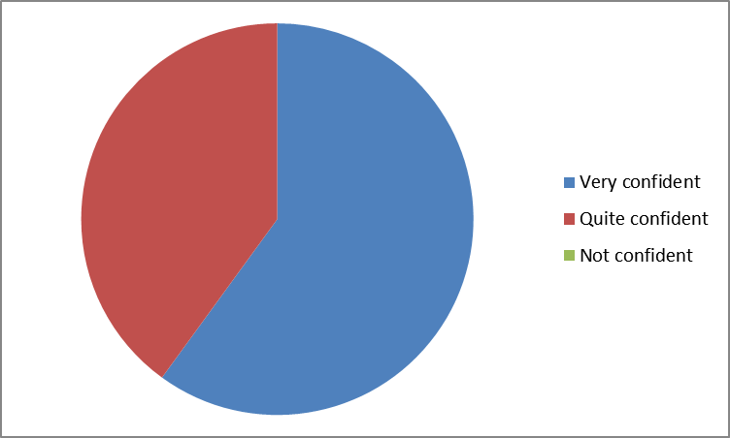
How often do you look at sound/number packets with your child?
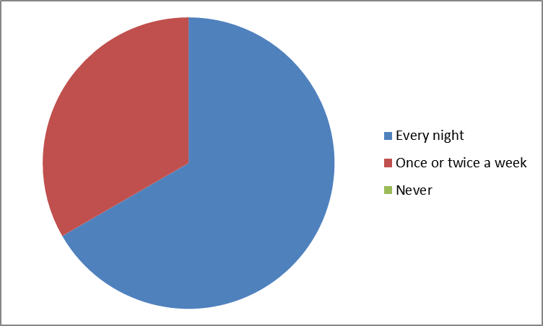
Which of these sources of advice on homework would you welcome and use if available?
