Northumberland Parking Enforcement Vehicle
'Be A Smarter Parker'
The council are re-introducing an enforcement vehicle to increase road safety within Northumberland. Shanklea Primary School and the surrounding areas will targeted as a hot spot!
The vehicle will be enforcing school keep clear restrictions from September 2016. It will be easily recognisable, displaying Northumberland County Council’s logo and a camera enforcement logo as well as the ‘Be a Smarter Parker’ branding.
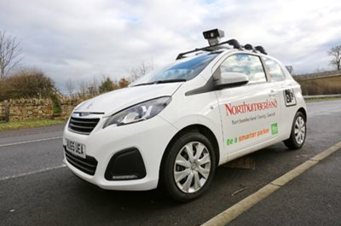
The vehicle will monitor schools' ‘keep clear’ zones and the camera will be used to capture vehicles breaking parking regulations. These vehicles will then be issued with a Penalty Charge Notice (PCN) by post.
Traffic and parking will always be an issue for us. Last week, there was a very near miss between a local resident and parent and we have recently received numerous complaints about parking.
In order to keep your children safe please can we ask that children are never left unsupervised outside the school gate, (even for a moment) and that you avoid parking in front of the school entrance and in local streets. Thank you.
Northumberland County Council has extended the resident-only parking zone for a further 6 months. Traffic Regulation Orders apply in the Nairn Road, Northolt Avenue, Needham Place, Newlyn Drive areas of Cramlington. Waiting and loading restrictions apply from 8.00-5.00p.m and there is a prohibition of driving except for access. Please check the traffic signs to make sure you don’t receive any penalty fines.

