Child Pedestrian Training
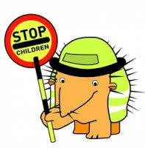
We have successfully worked in partnership with the Northumberland Highways Department and Christine Wilson, (Education) delivering Child Pedestrian training for several years.
Year 1 children are taken out in groups on to local roads by a trained tutor to talk about road safety and take part in practical activities. It is a wonderful opportunity for the children and gives them a chance to ask questions in a very small group. Christine Wilson has also trained several Teaching Support Assistants.
The 10 week programme delivers on-road practical training on the safer places to cross the road in the community, together with classroom-based sessions confirming how to be safe and when and where to cross the road, together with confirming the dangers of road traffic.
Outdoor sessions require close supervision, with each route being carefully risk-assessed so children are taken out in small groups, supported by local school volunteers who are all disclosure and barring service (DBS) cleared.

Each year, our school participates with the Kerbcraft programme, training approximately children children. Schools are subsequently revisited, and the children are provided with a refresher talk.
Additionally, pre-school children also undertake Kerbcraft training within nursery and reception classes, where approximately 100 children are given road safety information.
All children at three years of age within Northumberland are provided with the book Stepping Out Together - A Lesson for Life. This is distributed via health visitors and clinics, Sure Start centres, nurseries and reception classes.

