Challenge Cards – cut and laminate each of the cards then give to children treasury tag/string to keep at home.
Feed the birds  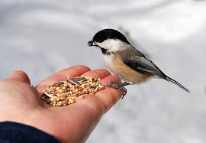  This helps me find out about living creatures that live in my world | Jump in puddles  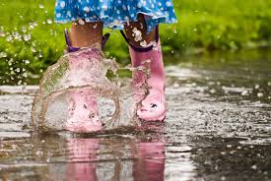  Jumping up and down helps me develop my sense of motion, distance and coordination | Snuggle under a blanket for stories at bedtime  This helps me learn to read and strengthen my bond with my special grown ups
Chalk on the pavement  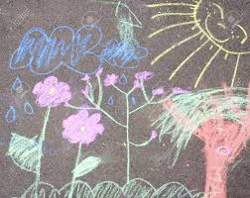  This helps me make my mark for later drawing and writing skills | Make tracks in sand or mud  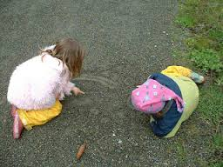  This helps me learn about patterns and shapes for later writing and drawing | Put your own shoes on  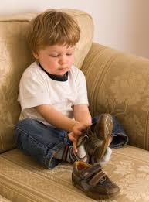  This helps me develop my independence to learn and do things for myself
Talk about the moon and stars on a night walk  This helps me learn about the world all around me | Build a really big sand castle  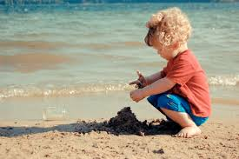  This helps develop my hand-eye coordination and understanding of size | Make a list and go shopping  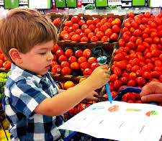  This helps me understand that my special marks can have meaning.
Learn and sing number rhymes like ‘1,2,3,4,5, once I caught a fish alive’  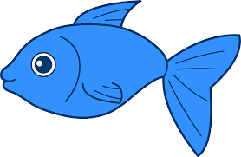  This helps me with my counting skills | Count the stairs as you walk to bed  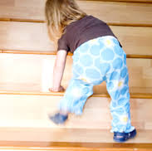  This helps me with my counting skills | Make mud pies  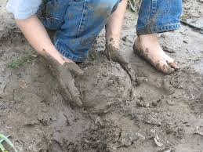  Messy play help stimulate the senses in my brain for learning
Sign your name (with your special marks) on a birthday card  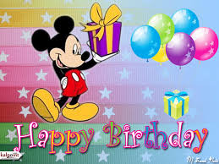  This helps me understand that my special marks can have meaning. | Eat something you have grown  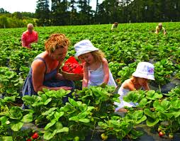  This helps my understand where food comes from | Make a collection of objects e.g. shells, tickets, leaves etc.  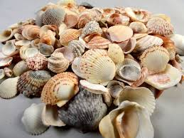  This helps me to develop my maths skills by sorting objects and looking at sizes, shapes and patterns
Blow the seeds off dandelion clocks  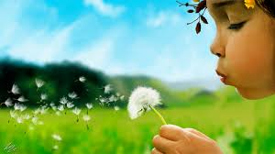  This helps me develop the muscles in my mouth so I can make all of the sounds I need for speaking | Learn and sing ‘Old MacDonald had a farm’  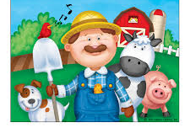  Imitating the sounds of things I have heard encourages me to listen closely to sounds which helps me learn to read | Sort the washing e.g. pair matching socks.  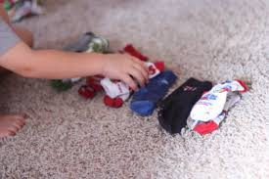  This helps me to develop my maths skills by sorting objects and looking at sizes and patterns
Join the library and borrow a book  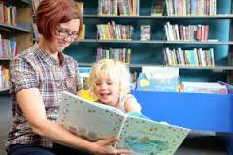  This helps me develop a love of books and an interest in the pictures I see | Make a reading tent to share stories in  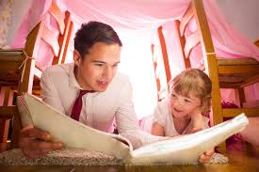  This helps me learn to read and strengthen my bond with my special grown ups | Pick daisies  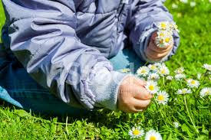  This helps me develop the muscles in my fingers and my understanding of how things grow
Go as high as you can on a swing  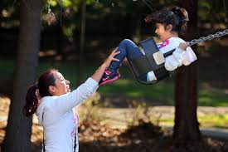  Swinging helps me develop my sense of motion, distance and coordination | Play ‘I spy’ to find objects in a book  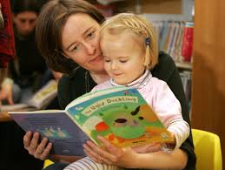  This helps me develop a love of books and an interest in the pictures I see | Play football  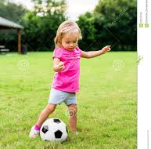  Exercising my muscles helps my brain to develop
Find minibeasts e.g. a wriggly worm  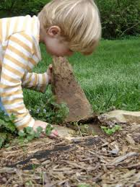  This helps me find out about living creatures that live in my world | Make a drum out of a tin can and beat it to your favourite song  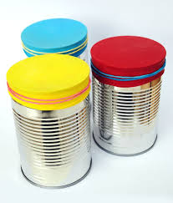  This helps me develop my sense of beat, rhythm and pattern. This helps me learn to read. | Paint on the ground with water & a brush  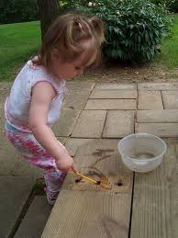  This helps me to develop my skills for writing and drawing
Do body painting e.g. hands  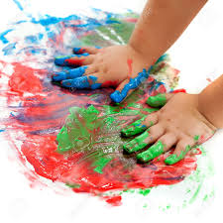  Messy play help stimulate the senses in my brain for learning | Throw stones in the sea or in a stream  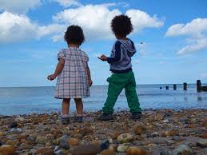  Exercising my muscles helps my brain to develop and helps me learn about distance, gravity and forces. | Make a picnic and take your teddy  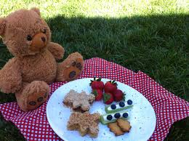  This helps me be independent to do things for myself and develops my skill at using tools like a knife to spread.

