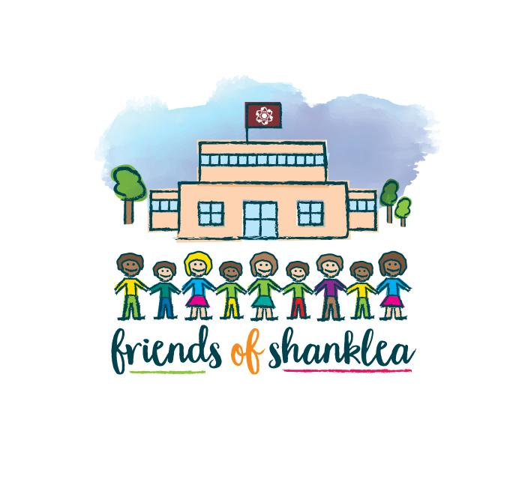

Minutes of Meeting
Wednesday 20th September 2017

Present: Sarah Willoughby, Jennifer Wealleans, Sarah Brown, Tracey Swithenbank, Angela Spedding
Apologies: Claire Bowart, Sarah Maddison, Emily Rigg, Joshua Rutherford

Chair – Sarah Willoughby  Secretary and Treasurer – Sarah Brown | Action
Sarah Willoughby opened the meeting by welcoming all members and thanking them for their attendance.

Two new members in attendance - Angela Spedding (Parent) and Tracey Swithenbank (Parent).

Introductions of members present.

Summer Fair feedback

The Summer Fair was a great success despite the weather. Extended hours worked very well, staggered the rush. Most stalls sold out before the event was due to end which resulted in the event closing up a little earlier than expected.
The two free attractions, the Magician and the Pony rides were popular and the having specified times for both was a good idea.
All members feel it is important to have some free events so that we give something back to the pupils and their families as a thank you for their continued support.

Financial Statement

A copy of the financial statement was presented and passed around the members present. Copy attached to minutes.

Future Dates

19/10/17 - Halloween Disco
24/11/17 - Non Uniform Day - Christmas Fair Donations
01/12/17 - Christmas Fair
08/02/17 - Valentines Disco
29/03/17 - Easter Event
06/07/17 - Summer Fair
19/07/17 - End of Year Disco

Halloween Disco

Halloween disco will take place on 19/10/17.
Help required to run the disco, G Force are booked in.
We will trial a ticketless system this time, utilising the gateway payment system already implemented in school. Parents can pay on the gateway, any who do not use gateway can pay at the school office and their details will be added to the gateway system by the office staff.
A register will be generated from gateway to use on the evening of the disco. A member of staff will be required to begin working down the queue ticking names off and checking payments made 10 minutes prior to the doors opening for each Key Stage.
A ticketless system will save on printing and paper waste. A paper register of pupils attending will improve the Safeguarding and Health and Safety procedures for the events. The safety of the children is of utmost importance.
JR to produce a Halloween Disco flyer.

Christmas Cards

The Christmas card design project will run again this year through Cauliflower Cards. Packs have already been delivered and are ready to give out to classes.
Children will design their cards in school. Designs will be sent home no later than 06/10/17 with the cut off date of 13/10/17 for orders to be returned to school.
Any helpers to check off the Christmas Cards against class lists and payment reports prior to being sent off for production will be appreciated.
Sarah Willoughby and Angela Spedding have offered to complete this task.
Last year Friends of Shanklea profited £300 from this project.

Christmas Fair

Christmas Fair will run on 01/12/17 5pm - 7pm.
New ideas to add the Wow factor welcomed.
The Tombola will be held in one of the classrooms probably AK4. Tombola is the most popular stall, other stalls placed elsewhere are often overlooked. During the Summer Fair other stalls in classrooms received less attendance. All members present agreed the Tombola would be popular wherever it was placed so to give other stalls the opportunity of attracting custom they would be in hall.

Stall/Attraction ideas for Christmas Fair

- Play Your Cards Right - Adult Attraction
- Hook A Bauble
- Snowball Bounce
- Cracker Game - Find the Raffle ticket
- Fruit Machine - Adapted to fit in with Christmas theme
- Hot Turkey Sarnies and Broth
- Santa’s Grotto
- Photo Booth

All members were asked to think of ideas for the fair and share them at the next meeting.

Giving Machine

The Giving Machine service is to be promoted throughout the School community. ideal time of year to promote this service to raise funds.
If you sign up through The Giving Machine and select “Shanklea” as your cause, everytime you shop online from certain sites you generate a donation for your cause.
The Giving Machine has an available app for IPhones and is currently creating an app for Android devices.
The link for The Giving Machine (www.thegivingmachine.co.uk) is to be added to the PTFA section of the school website if HB agrees as a way to promote the service.
The service will be promoted through Newsletters and posters.

Parental Questionnaire

PTA UK have created a Parental Questionnaire for schools to send home, to gather information on events pupils and parents like to and would like to attend. The questionnaire encourages parental suggestions, thought and issues with PTFA events. There are also questions on parents skills and interests.
Angela agreed to adapt the questionnaire as all members present felt the questionnaire printed was to wordy which would put parents off responding. The questionnaire will hopefully help us create a skills matrix for parents so we have an idea of who we can call upon for future events and other fundraising routes.

Friends Of Shanklea Newsletter

The production of a termly newsletter is something which we have discussed on many occasion. All agree it is something we should have. It is a great way to promote the FOS events we have and will be running and will be a useful tool of communication for recruiting new members and keeping pupils and parents up to date on how the funds raised are allocated and spent.
Angela Spedding offered to create a newsletter template. Sarah Brown will provide details on past purchases, upcoming diary dates and the FOS logo.

DBS Checks
Members of Friends of Shanklea are required to have DBS checks completed. Sarah Brown will make contact with members who require DBS checks or who need a DBS renewal.

Actions to be followed up (so far)

- JR to produce Halloween Disco Flyer
- SBr to set up ticketless system for Halloween Disco
- SW & AS to purchase food and drinks to be sold at the Halloween Disco
- All to consider stall ideas for the Christmas Fair
- All to contact companies and source raffle prizes for Christmas Fair
- SBr to check with MH re: Hot turkey Sandwiches and Broth to be sold at Christmas Fair
- SBr to discuss idea of Giving Machine link to be added to PTFA section of school website.
- AS to revise Parent Questionnaire in hope to send out within the next few weeks
- AS to create template for Newsletter
- SBr to check on DBS requirements and make contact with relevant members.

Next meeting date

Wednesday 1st November 2017, as we appear to struggle to accommodate all members attendance at 3.30pm meetings, a suggestion was made to meet off site later in the evening (approx 6pm) in an attempt to accommodate as many attending member s as possible. Please respond with your thoughts regarding this.

