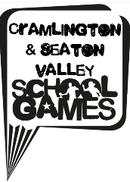
Key Steps to success in gymnastics

Northern Gymnastics Club in Cramlington once again hosted our School Games Level 2 Y3/4 Gymnastics. This was a fantastic opportunity for pupils to show off the routines they had been practicing at school in a fully equipped professional gymnastics centre. Each of the 12 teams performed their two Key Steps gymnastics floor routines, in front of the judges. It was obvious that a tremendous amount of practice had taken place beforehand. The Northern Gymnastics Coaches had also set up a variety of gymnastics activities for the teams to try when they were waiting to compete. These were supported by sports leaders from Cramlington Learning Village who did a fantastic job of encouraging the younger pupils and introducing them to new skills.
The standard of performance was exceptionally high, with many gymnasts scoring more than 9 out of 10 for both of their routines. All of the children did very well to control their nerves and remember the routines. For many this was a first experience of gymnastics competition and a super introduction to the School Games.
Northburn A were the overall winners and will go on to represent Cramlington & Seaton Valley at the Northumbeland School Games finals in June.
RESULTS

- Northburn A
- Cragside
- Eastlea
- Burnside A
- Beaconhill A
- Shanklea
- Hareside A
- Northburn B
- Beaconhill B
- Hareside B
- Burnside B
- Burnside C

.

