Do you believe homework is an important part of primary school life?
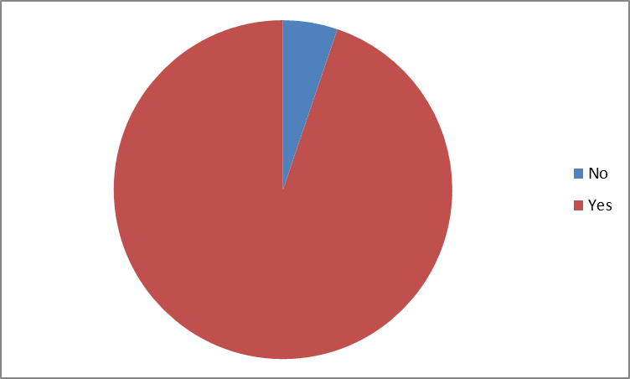
If you answered yes, please tick your reason as to why you think it is important:

Do you think the homework given each week is:
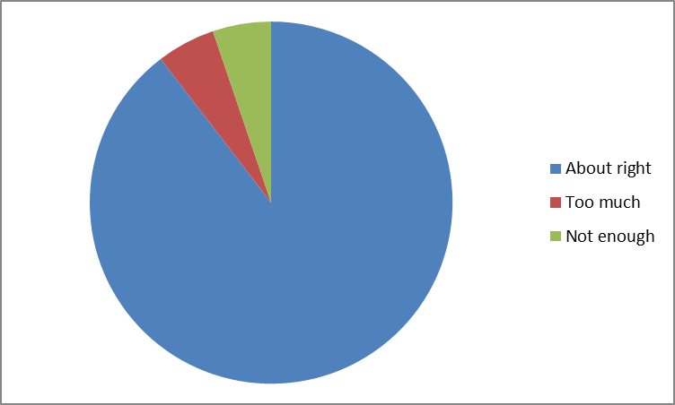
My child finds the level of the homework:
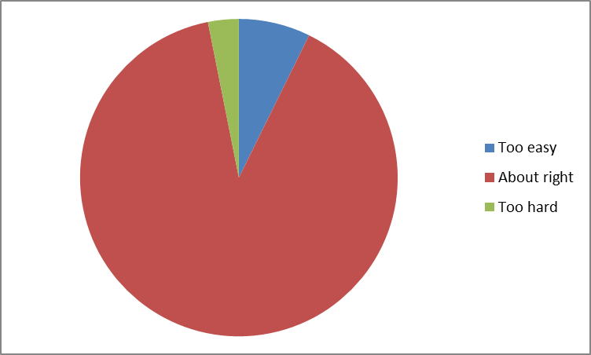
Do you have access to online homework?

Which part of English homework do you think helps your child’s learning most:
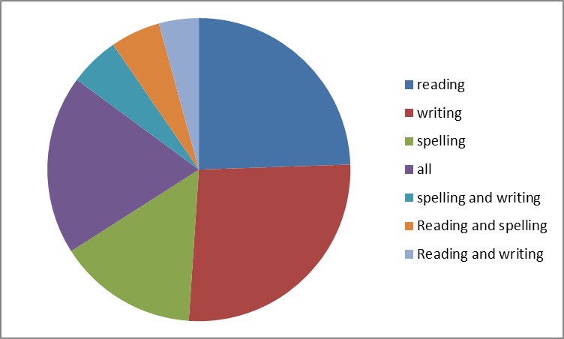
How often do you listen to your child read each week?
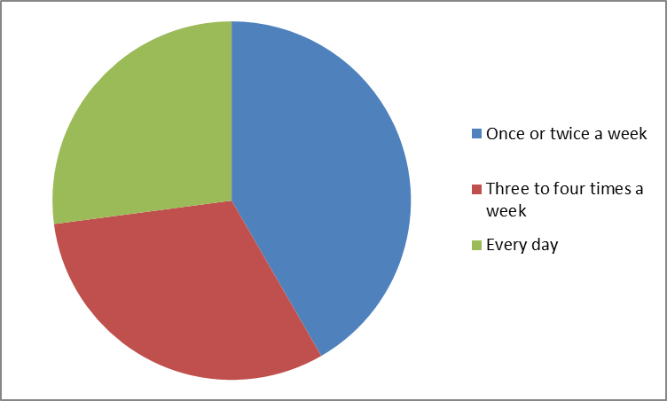
How confident are you in supporting your child with reading?
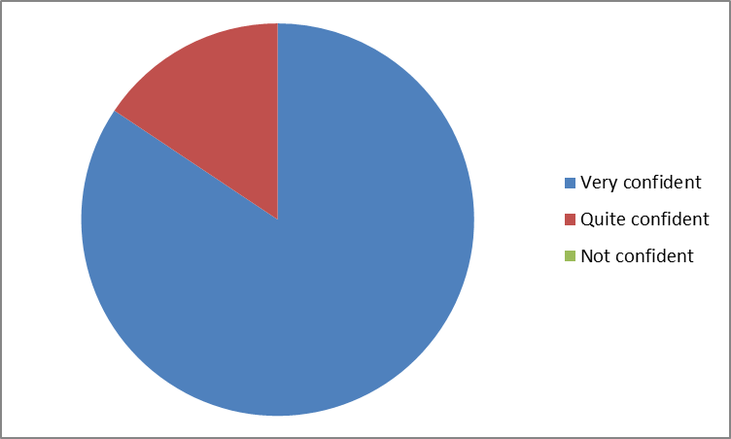
Which part of Maths homework do you think helps your child’s learning most:
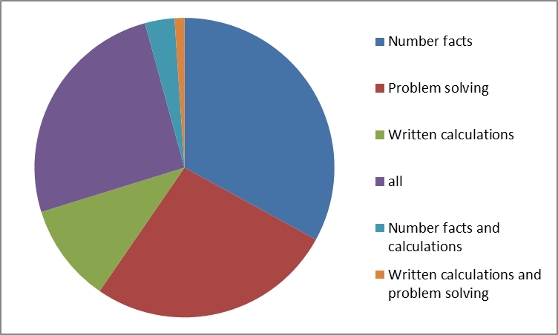
Which of these sources of advice on homework would you welcome and use if available?
