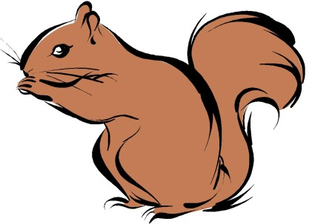

# 30

# Things To Do Before You’re

# 3

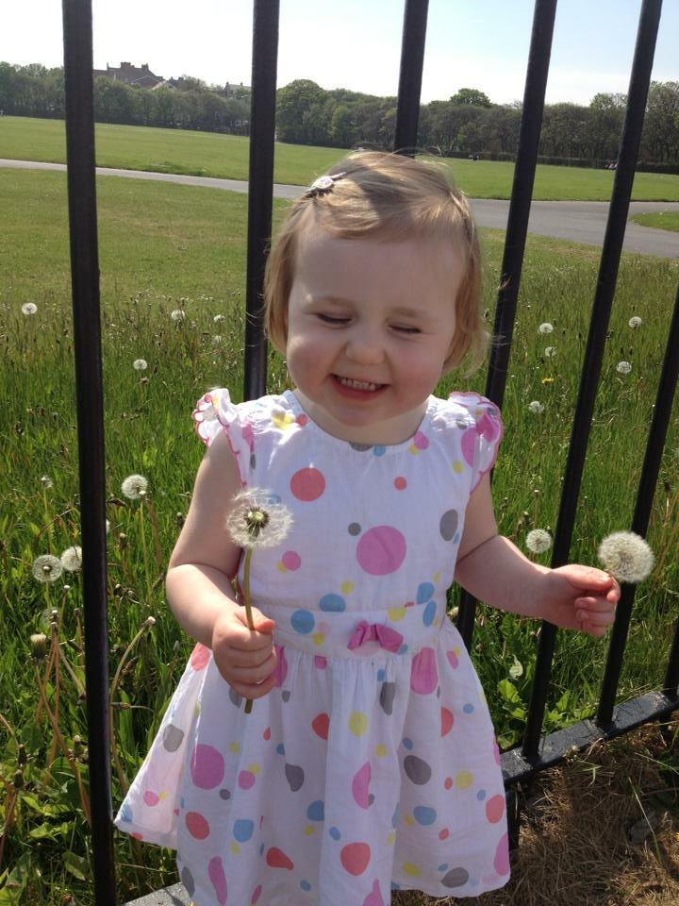

Child’s name:

……………………….………

Age:

……………………………….

Post code:

………………………………

Setting Attended

**Shanklea Squirrels**

………………………………

## Why take the ‘30 Things To Do Before You’re 3’ Challenge?

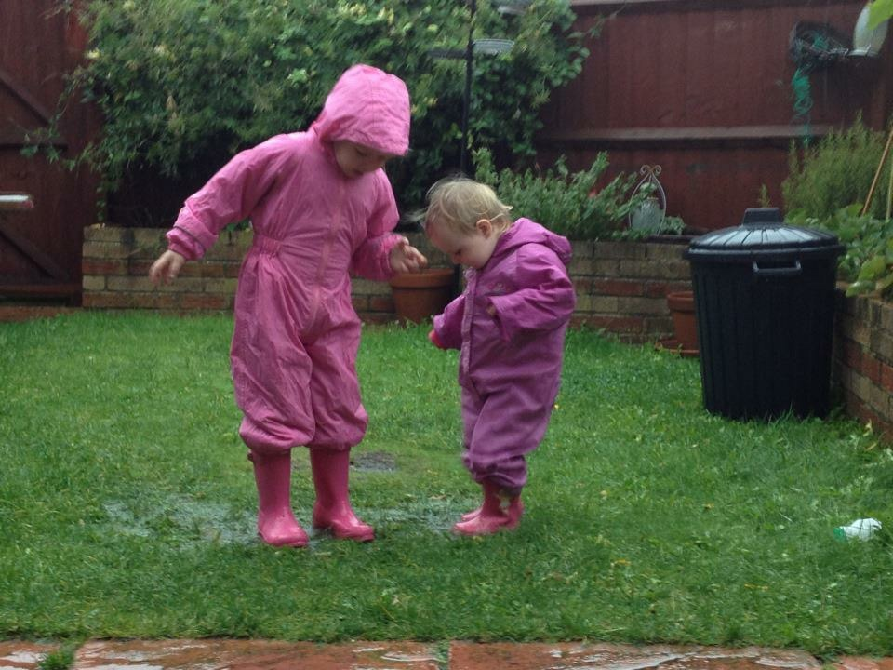

Parents are the first and most important influence on their child’s development and future achievements. This means that having fun playing, talking and reading with your child everyday will help them be happier, learn more and enjoy a better start in life.

Take the ‘30 things to do before you’re 3’ challenge with your child and ask your child’s setting to stamp their passport each time they complete one of the activities listed. Not only will you both have fun, but it will help your child in their readiness for school!

## My passport for the 30 things to do before you’re 3 challenge



### List 2

|  |  |
| --- | --- |
| Jump in puddles |  |
| Make tracks in sand or mud |  |
| Build a really big sand castle |  |
| Count the stairs as you walk to bed |  |
| Eat something you have grown |  |
| Learn and sing ‘Old MacDonald had a farm’ |  |
| Make a reading tent to share stories in |  |
| Play ‘I spy’ to find objects in a book |  |
| Make a drum out of a tin can and beat it to your favourite song |  |
| Throw stones in the sea or in a stream |  |

### List 1

|  |  |
| --- | --- |
| Feed the birds |  |
| Chalk on the pavement |  |
| Talk about the moon and stars on a night walk |  |
| Learn and sing number rhymes like ‘1,2,3,4,5, once I caught a fish alive’ |  |
| Sign your name (with your special marks) on a birthday card |  |
| Blow the seeds off dandelion clocks |  |
| Join the library and borrow a book |  |
| Go as high as you can on a swing |  |
| Find minibeasts e.g. a wriggly worm |  |
| Do body painting e.g. hands |  |

### List 3

|  |  |
| --- | --- |
| Snuggle under a blanket for stories at bedtime |  |
| Put your own shoes on |  |
| Make a list and go shopping |  |
| Make mud pies |  |
| Make a collection of objects e.g. shells, tickets, leaves etc |  |
| Sort the washing e.g. pair matching socks. |  |
| Build a tower with bricks, cups, pebbles |  |
| Play football |  |
| Paint on the ground with water & a brush |  |
| Make a picnic and take your teddy |  |

# 30 Things To Do Before You’re 3

For information on open positions or to submit your resume, please visit our Web site at: www.lucernepublishing.com