Early Years Quality Mark Award
In addition, we are also celebrating the work of everyone involved with the EYFS setting in making progress and in improving the quality of its provision for the young children in its care and the standards they achieve. As exemplary early years providers, we continually think about how to improve what we are offering to young children and their families.
We have been recognised for:
1. A whole-setting strategy and planning to improve young children’s abilities and achievements in their foundation skills.
2. Analysis of the assessment of young children’s abilities and achievements.
3. Setting appropriately high expectations for young children’s development.
4. Planning ‘next steps’ in learning for young children’s development.
5. Regular review of the progress made by all young children.
6. A commitment to improving the skills of all practitioners.
7. A balanced use of child-initiated and adult-led, play-based activities.
8. The use of appropriate environments and resources.
9. Partnership working between families, carers, practitioners and professionals in supporting young children’s learning and development.
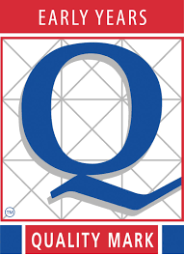
10. An effective procedure for monitoring planning and assessing improvement in practice and provision.

