Shanklea Out of School Club Long Term Overview
Autumn term 2 2016
 | Monday | Tuesday | Wednesday | Thursday | Friday
Week1 Commencing 31st October  OSSC Theme: WW1 | Halloween activities | WW1: Investigating World War 1  Bully Beef toasted sandwiches | WW1 trench life/on the front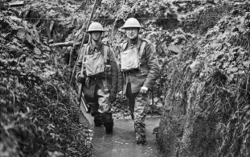 | WW1 Source types/decoding/ | Soldiers diary/letters home
Week 2  Commencing 7th November  OSSC Theme: WW1 | WW1 poetry/ Flounders fields/ | My local war memorial  Trench cake and a cup of tea | Poppy wreath | Poppy wreath – visit to the war memorial | Remembrance day activities
Week 3  Commencing 14th November  OSSC Theme: WW1 | Getting to no WW1 : a closer look | Newspaper articles: stories from 1914  Spam fritters | A race to Sea | Code Breakers | No man’s land
Week 4  Commencing 21st November  OSSC Theme: WW1 | The forces: RAF and the Army | WW1 medals  Ham and egg pie | The Red Baron | The British Army | WW1 : A troops Christmas
Week 5  Commencing 28th November  OSSC Theme: WW1 | WW1 Christmas card/letter home  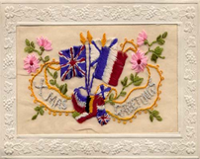 | WW1: A soldiers diary entry  Sweet mince pie and cream | WW1 : The Christmas truce | OOSC: Late night shopping event | WW1: Christmas parcels from home
Week 6  Commencing 5th December  OOSC Theme: Victorian Christmas | Victorian Christmas | Peppermint creams | Victorian Christmas  crackers | Christmas cards | Christmas fayre: OOSC Victorian Christmas stall
Week 7  Commencing 12th December  OSSC Theme: Victorian Christmas | Victorian Christmas | OOSC Christmas party  Sausage rolls, sandwiches, cakes, crisps and juice | decorations/singalong  Christmas | decorations/singalong  Christmas | Christmas  carols/stories

